Link: <http://www.studytonight.com/computer-networks/tcp-ip-reference-model>

**TCP/IP Model**

Replace the given image with:

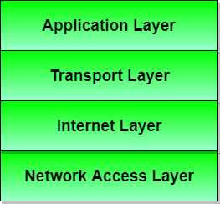

Add one more image:

**Protocols and networks in the TCP/IP model initially:**

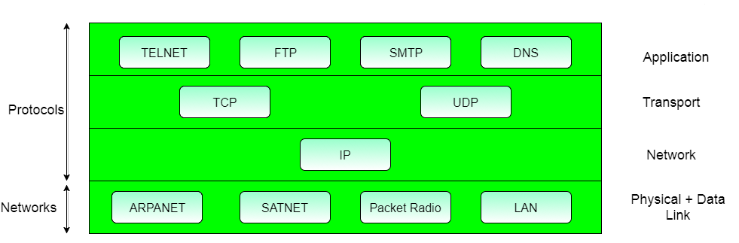

#### Under: Layer 2: Internet layer

Add more points

* The various **functions** performed by the Internet Layer are:
  + Delivering IP packets
  + performing routing
  + avoiding congestion

#### Under: Layer 3: Transport Layer

Add more points:

* It allows **peer** entities to carry conversation.
* It defines two end-to-end protocols: TCP and UDP
  + **TCP (Transmission Control Protocol)**: It is a reliable connection-oriented protocol which handles byte-stream from source to destination without error and flow control.
  + **UDP (User-Datagram Protocol)**: It is an unreliable connection-less protocol that do not want TCPs, sequencing and flow control. Eg: One-shot request-reply kind of service.

**Rest of the content is Perfect!**